Emotional Speech Detector

By
Reem Basho
Yasmine Hariri
Rand Al Yaman
Mahdi Dagher

A Capstone Project
submitted in fulfillment of the requirements
for the AI Bootcamp

Beirut, Lebanon

An Abstract of the Capstone Project

Title: Emotional Speech Detector

The ability to detect emotions from speech is a vital step toward creating more natural and human-centered interactions between people and machines. Emotional Speech Detection (ESD) has wide applications in call centers, healthcare, education, and assistive technologies. However, accurately classifying emotions from audio signals remains a challenge due to background noise, variability in speakers, and overlapping acoustic patterns among emotions.
In this project, we designed and implemented an emotional speech detector using publicly available datasets of labeled speech samples. The raw audio was preprocessed through normalization, silence removal, and transformation into acoustic features such as Mel-Frequency Cepstral Coefficients (MFCCs), chroma features, and spectrograms. Several machine learning and deep learning models were explored, including Random Forest classifiers, Convolutional Neural Networks (CNNs), and Long Short-Term Memory (LSTM) networks, to identify the most effective approach for speech emotion recognition.
Our findings show that deep learning models and machine learning models achieved similar accuracy performances. However, deep learning models, particularly CNN outperformed, outperformed other models in accuracy. Nonetheless, we chose a machine learning model, SVM, as our final choice due to its diagonal accuracy in said heatmap matrix compared to overfitted machine learning models. This could be due to the fact that machine learning models are specialized in classifications. Across speaker-independent splits on the target corpora, a Support Vector Machine (SVM) classifier achieved the best overall performance (highest macro-F1 and UAR), outperforming the tree-based and neural baselines. The system demonstrated strong performance in detecting emotions such as happiness, anger, and sadness, while still facing challenges in distinguishing more subtle categories like fear or disgust.
The results of this project highlight the importance of feature representation and model selection in speech-based emotion recognition. Beyond academic exploration, this work contributes to practical applications in real-time human-computer interaction and lays the foundation for future improvements through larger datasets, multilingual support, and more advanced models such as transformer-based architectures.
Table of Contents
1. Introduction 6
1.1 Importance of Emotional Speech Detection 6
1.2 Problem Statement and Challenges 6
1.3 Objectives of the Project 6
1.4 Literature Gap and Novelty 6
2. Background and Related Work 7
2.1 Fundamentals of Speech Emotion Recognition 7
2.2 Feature Extraction in Emotional Speech Detection 8
2.3 Classical Machine Learning Approaches 8
2.4 Deep Learning Approaches 8
2.5 Commonly Used Datasets 8
2.6 Gaps in Existing Research 9
2.7 Positioning of Our Work 9
3. Methodology 9
3.1 Materials, Software, and Equipment Used 9
3.2 Data 12
3.2.1 Data Sources 12
3.2.2 Data Cleaning Pipeline 13
3.3 Techniques and Approaches 18
3.3.1 Data Integration & Harmonization 18
3.3.2 Audio Preprocessing 18
3.3.3 Feature Extraction 18
3.3.4 Modeling Approaches 19
3.3.5 Training & Evaluation 21
3.3.6 Exploratory Data Analysis (EDA) 21
3.4 Reproducibility 27
4. Results 27
4.1 Convolutional Neural Network (CNN) 27
4.1.1 Training and Validation Performance 27
4.1.2 Confusion Matrix 28
4.1.3 Summary of Results 29
4.2 Long Short-Term Memory (LSTM) 30
4.2.1 Hyperparameter Tuning 30
4.2.2 Training and Validation Performance 32
4.2.3 Confusion Matrix 32
4.2.4 Summary of Results 33
4.3 CNN + LSTM Hybrid Model 33
4.3.1 Architecture & Training Setup 34
4.3.2 Training and Validation Performance 34
4.3.3 Test-Set Performance 34
4.3.4 Confusion Matrix Analysis 35
4.3.5 Summary of Results 36
4.4 Support Vector Machine (SVM) 36
4.4.1 Hyperparameter Tuning 37
4.4.2 Training and Testing Performance 37
4.4.3 Confusion Matrix 38
4.4.4 Summary of Results 39
4.5 Random Forest Classifier 40
4.5.1 Hyperparameter Tuning 41
4.5.2 Training and Testing Performance 41
4.5.3 Summary of Results 42
5 Conclusion 44
6 References 45

Table of Figures
Figure 1: Emo-DB Dataset count 9
Figure 2: CREMA-D dataset count 9
Figure 3: RAVDESS Dataset count 10
Figure 4: Resampling and Normalization 13
Figure 5: Data after silence trimming 14
Figure 6: Noise Reduction 14
Figure 7: Deterministics 15
Figure 8: Audio Segmentation 16
Figure 9: Label Distribution 21
Figure 10: Emotion Label Distribution by Gender 22
Figure 11: Pitch Distribution by Label 23
Figure 12: Energy Distribution By label 24
Figure 13: Distribution of Data Splits 25
Figure 14: Model Loss and Accuracy Graph 27
Figure 15: Confusion Matrix 27
Figure 16: Final Accuracy, Precision, recall, and F1-score 29
Figure 17: Hyperparameter Tuning that shows hidden units, number of layers, dropout rate, sequence length, and learning rate 30
Figure 18: Model Accuracy and Loss Graphs 31
Figure 19: Confusion Matrix post-Hyperparameter tuning 31
Figure 20: accuracy and loss graphs 33
Figure 21: classification report 34
Figure 22: confusion matrix 35
Figure 23: accuracy after hyperparameter tuning. 36
Figure 24: Training, Validation, and Testing results 36
Figure 25: mfcc Statistics 37
Figure 26: confusion matrix before hyperparameters 37
Figure 27: confusion matrix post hyperparameters 38
Figure 28: Precision, Recall, and F1-Score 39
Figure 29: Accuracy Post Hyperparameters Tuning 39
Figure 30: Best Hyperparameters 40
Figure 31: Hyperparameter Numbers 40
Figure 32: Training Accuracy and Statistics 40
Figure 33: Testing Accuracy 41

Introduction

1.1 Importance of Emotional Speech Detection
Speech is not only a way to exchange words but also a natural carrier of human emotions. The tone, pitch, rhythm, and intensity of voice often reveal more about a person’s state of mind than the actual content of the speech. Recognizing emotions from speech is an essential component for creating intelligent systems that can interact with humans in a more natural, empathetic, and context-aware manner. Emotional speech detection (ESD) has practical applications in diverse fields such as customer service, healthcare, education, entertainment, and assistive technologies. For example, an emotional detector could help call centers monitor customer satisfaction, assist doctors in identifying stress or depression in patients, and support language-learning tools in offering more personalized feedback.

1.2 Problem Statement and Challenges
Despite its importance, accurately detecting emotions from speech is a challenging task. Emotions can vary significantly from one speaker to another depending on gender, age, accent, cultural background, and speaking style. Environmental factors such as background noise or recording quality also affect the clarity of emotional cues in the audio signal. Moreover, some emotions—such as sadness and fear—share similar acoustic characteristics, which increases the difficulty of classification. Existing systems often face limitations in generalization, robustness, and scalability, making them less reliable in real-world applications.

1.3 Objectives of the Project
The primary objective of this project is to design and implement an Emotional Speech Detector capable of classifying audio recordings into different emotional categories. Specifically, the project aims to:
- Preprocess raw speech signals to improve audio quality and remove noise.
- Extract meaningful acoustic features such as Mel-Frequency Cepstral Coefficients (MFCCs), spectrograms, and chroma features.
- Build and evaluate different machine learning and deep learning models to classify emotions.
- Compare model performances and identify which approach provides the best balance between accuracy, efficiency, and generalization.

1.4 Literature Gap and Novelty
Previous research in the field has demonstrated the potential of various methods for speech emotion recognition. Traditional machine learning classifiers like Support Vector Machines (SVMs), Decision Trees, and Random Forests have shown good results on smaller datasets but often fail to scale well or handle complex acoustic patterns. More recently, deep learning methods, including Convolutional Neural Networks (CNNs) and Long Short-Term Memory (LSTM) networks, have improved accuracy by learning higher-level feature representations directly from raw or transformed audio. However, many existing approaches either depend on very large datasets, lack robustness in noisy conditions, or show poor generalization to unseen speakers. This project contributes by experimenting with multiple models, analyzing their strengths and weaknesses, and proposing improvements that could support real-world applications.
1.5 Contributions of This Project
To address these challenges, our project follows a systematic workflow. The first step involves preparing the dataset and applying preprocessing techniques such as normalization, silence trimming, and noise reduction. Next, feature extraction methods like MFCCs and spectrogram analysis are applied to represent audio signals in a machine-readable form. Multiple classification models, including both machine learning and deep learning approaches, are then trained and evaluated. Finally, results are compared using metrics such as accuracy, precision, recall, and confusion matrices to determine the most effective solution. This structured approach ensures a comprehensive evaluation of the problem and provides insights into the factors that influence the success of emotional speech detection systems.

Background and Related Work

2.1 Fundamentals of Speech Emotion Recognition
Speech Emotion Recognition (SER) is an interdisciplinary research area that combines signal processing, psychology, and artificial intelligence. It focuses on identifying the emotional state of a speaker by analyzing voice characteristics such as pitch, energy, rhythm, and spectral features. Unlike text-based sentiment analysis, which depends on word choice, SER leverages the acoustic and prosodic features of speech that convey affective information. Commonly recognized emotions include happiness, sadness, anger, fear, surprise, and neutrality. Understanding these signals is crucial for building systems that respond to humans in a more natural and empathetic way.

2.2 Feature Extraction in Emotional Speech Detection
One of the most important steps in SER is feature extraction, where raw audio signals are transformed into representations that capture emotional cues. Traditional features include prosodic features (pitch, loudness, duration), spectral features (formants, energy distribution), and Mel-Frequency Cepstral Coefficients (MFCCs), which mimic the human ear’s sensitivity to frequencies. Advanced approaches often rely on spectrograms and chroma features, which provide a visual or frequency-based representation of sound. Research has shown that the choice of features significantly affects classification accuracy, with MFCCs being one of the most widely used due to their robustness and efficiency.

2.3 Classical Machine Learning Approaches
Early work in SER relied on classical machine learning algorithms, where hand-crafted features were used as input. Algorithms such as Support Vector Machines (SVMs), Decision Trees, K-Nearest Neighbors (KNN), and Random Forests achieved reasonable accuracy on small, controlled datasets. These models are computationally lightweight and easier to interpret but often lack the ability to capture complex, non-linear relationships in speech data. Their performance tends to drop significantly when applied to larger or more diverse datasets, making them less suitable for real-world scenarios.

2.4 Deep Learning Approaches
With the advancement of computational power and availability of larger datasets, deep learning methods have become the dominant approach in SER. Convolutional Neural Networks (CNNs) are frequently used because they can learn spatial patterns from spectrograms, while Recurrent Neural Networks (RNNs) and their variants such as Long Short-Term Memory (LSTM) networks excel at modeling temporal dependencies in speech. Hybrid models that combine CNNs and LSTMs have shown promising results by leveraging both spatial and sequential patterns. Recent research has also explored transformer-based architectures and pre-trained speech models (e.g., wav2vec 2.0), which outperform traditional methods by capturing richer contextual representations.

2.5 Commonly Used Datasets
Several benchmark datasets have been developed for SER research. The RAVDESS (Ryerson Audio-Visual Database of Emotional Speech and Song) is widely used, containing high-quality recordings of actors expressing different emotions. IEMOCAP (Interactive Emotional Dyadic Motion Capture Database) provides both audio and visual data for dyadic conversations. Other datasets like CREMA-D and EMO-DB contribute to diversity in speaker accents and emotional categories. These datasets form the basis for most experimental evaluations and allow fair comparisons between different approaches.

2.6 Gaps in Existing Research
Although significant progress has been made, several challenges remain in the field of SER. Many existing systems rely on acted emotions, which may not fully represent spontaneous human expression. Models also struggle with cross-lingual generalization, as most datasets are limited to English. Furthermore, background noise and class imbalance often reduce accuracy in practical applications. Current literature highlights the need for models that are both accurate and robust across different languages, accents, and environments.

2.7 Positioning of Our Work
This project builds on existing approaches by exploring a combination of feature extraction techniques and classification models. By comparing the performance of machine learning and deep learning approaches, we aim to identify the most effective pipeline for emotion recognition in speech. Our contribution lies not only in implementing these models but also in evaluating their strengths and weaknesses in terms of accuracy, generalization, and real-world applicability

Methodology
We describe the datasets and software stack, then detail preprocessing, feature extraction, model architectures, and evaluation strategy. All splits are speaker-independent, and all models are trained on the same features/splits unless otherwise stated, enabling fair comparison.

3.1 Materials, Software, and Equipment Used
Datasets
We used three publicly available emotional speech datasets:
- RAVDESS: North American English speech with 8 emotion classes (Figure 3).
- CREMA-D: US English speech with demographic metadata (age, gender, ethnicity), (Figure 2).
- EmoDB: German emotional speech with 7 emotion classes (Figure 1).
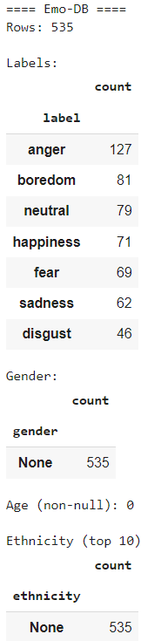
Figure 1: Emo-DB Dataset count
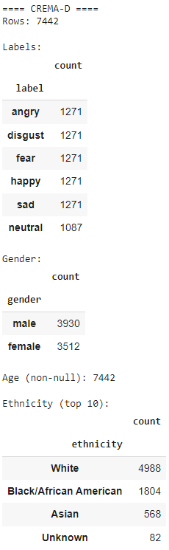
Figure 2: CREMA-D dataset count

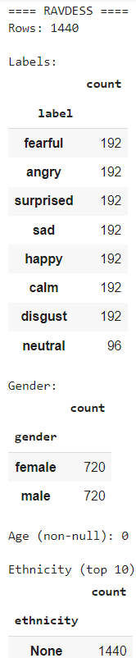
Figure 3: RAVDESS Dataset count

These datasets were merged into a unified manifest with harmonized labels and speaker metadata. A speaker-independent split was applied to avoid overfitting to individual voices. Merging the three corpora into a single manifest allowed us to harmonize labels, track demographics where available, and ensure that speakers remained exclusive to train/val/test sets. This grouped-by-speaker policy reduces leakage from overlapping segments and better reflects real-world deployment where users are unseen at train time.

Software & Libraries
The stack balances classical and deep learning needs: feature extraction, ML baselines (SVM, RF), and CNN/LSTM prototypes. Versioned notebooks and a fixed random seed ensure reproducibility.
- Google Colab: Cloud-based development environment with GPU acceleration.
- Python 3.10: Core programming language.
- Libraries:
  - librosa, soundfile: Audio loading, trimming, and feature extraction.
  - torchaudio, torch: Deep learning and audio I/O.
  - opensmile: Extracted pitch, energy, and prosodic features.
  - torch-audiomentations: Applied deterministic cleaning (high-pass, low-pass, peak normalization).
  - scikit-learn, matplotlib, seaborn: Data analysis and visualization.
  - tensorflow.keras: Model design and training.

Preprocessing Pipeline

We standardized every file to 16 kHz, removed trailing/leading silence, and reduced stationary noise via Wiener filtering. Deterministic cleaning (HP/LP filtering and peak normalization) further stabilized loudness and spectral content. Finally, we segmented audio into 3-second windows with 50% overlap, increasing sample count while preserving temporal context; segments from the same utterance were kept within a single split to avoid leakage.

Model Architectures

We evaluated a feature-driven family against representation learners in hopes of comparing different models. For classical models, MFCC statistics formed compact inputs; for deep models, we used MFCC sequences or spectrograms to exploit spatial/temporal patterns. This design isolates which approach best fits our data size and class balance.

1. Baseline CNN
- Input: MFCC mean vectors.
- Architecture: Conv1D → MaxPooling → Dense → Softmax.
- Purpose: Capture spatial patterns in audio features.
2. CNN + LSTM Hybrid
- Input: Full MFCC sequences over time.
- Architecture: CNN layers → LSTM → Dense → Softmax.
- Purpose: Capture both spatial and temporal emotional cues.

3.2 Data

3.2.1 Data Sources
We used three benchmark emotional speech datasets to ensure diversity in language, speaker demographics, and emotional expression:
1. RAVDESS (Ryerson Audio-Visual Database of Emotional Speech and Song)
- Language: North American English
- Emotions: Neutral, calm, happy, sad, angry, fearful, disgust, surprised
- Metadata: Gender inferred from actor ID (odd = male, even = female)
- Source: Downloaded from Zenodo
2. CREMA-D (Crowd-sourced Emotional Multimodal Actors Dataset)
- Language: US English
- Emotions: Angry, disgust, fear, happy, neutral, sad
- Metadata: Age, gender, ethnicity from VideoDemographics.csv
- Source: Downloaded from Kaggle
3. EmoDB (Berlin Database of Emotional Speech)
- Language: German
- Emotions: Anger, boredom, disgust, fear, happiness, sadness, neutral
- Metadata: Speaker ID inferred from filename
- Source: Downloaded from emodb.bilderbar.info
To unify label taxonomies, we mapped synonymous tags (e.g., happiness→happy) and preserved available metadata (age, gender, ethnicity). This enabled slice analyses and improved interpretability of confusion patterns across datasets.
Each dataset was parsed into a structured manifest CSV containing:
- File path
- Emotion label (standardized)
- Speaker ID
- Gender, age, ethnicity (when available)
- Dataset origin

3.2.2 Data Cleaning Pipeline
To ensure consistency and improve model performance, we applied the following cleaning steps to all audio files:
1. Resampling (Figure 4)
- Tool: torchaudio
- Action: Resampled all audio to 16kHz to standardize sample rate across datasets.

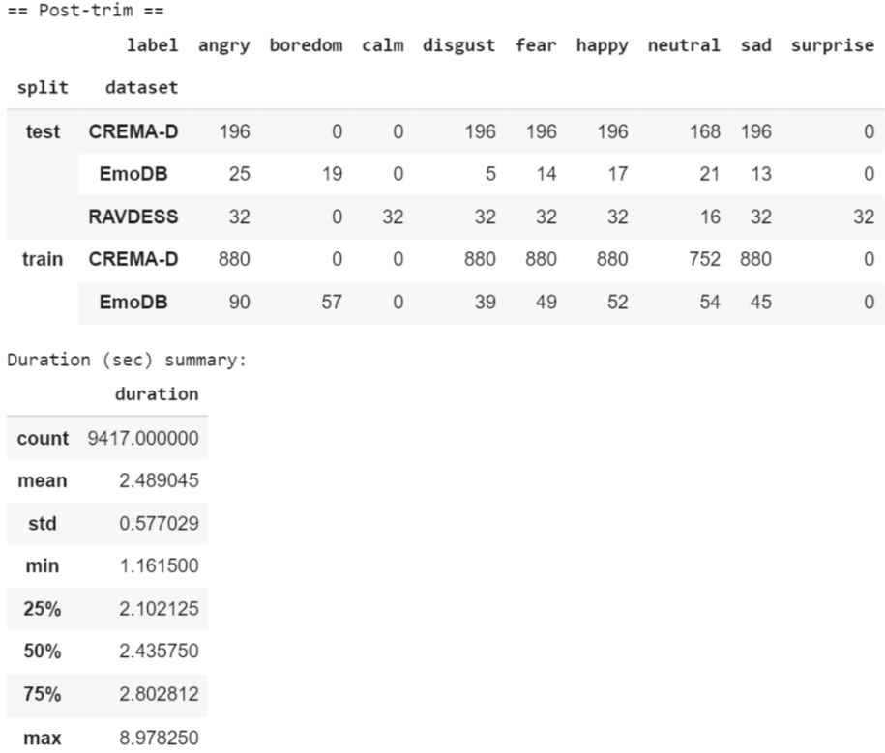
Figure 4: Resampling and Normalization
Figure 4 shows the effect of resampling all audio to 16kHz, ensuring consistency across datasets and preparing inputs for feature extraction.

2. Silence Trimming (Figure 5)
- Tool: librosa.effects.trim
- Action: Removed leading and trailing silence using a decibel threshold of 40 dB.
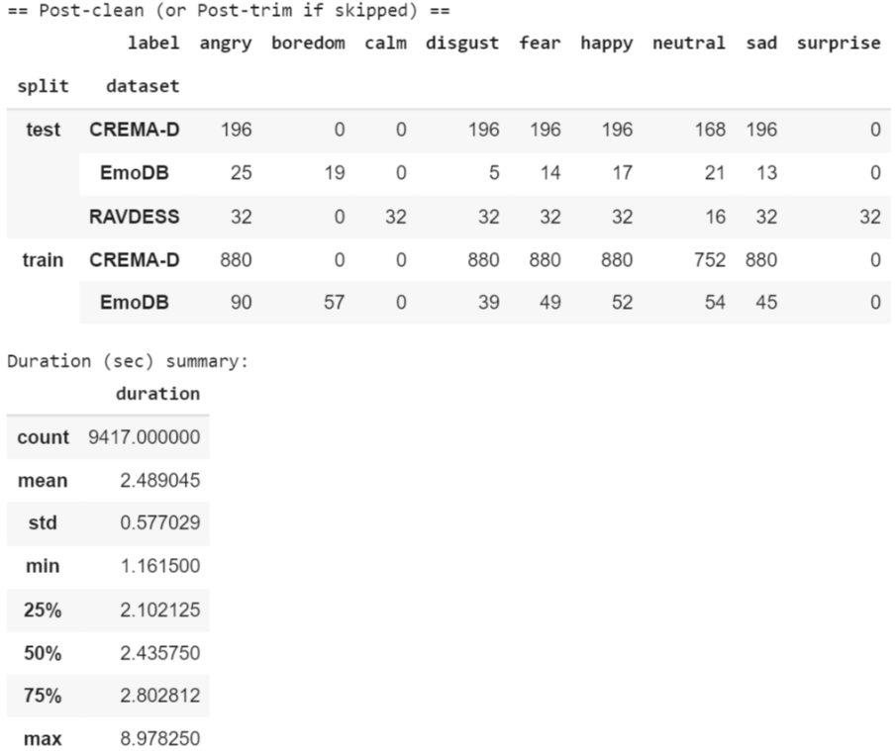
Figure 5: Data after silence trimming
Figure 5 illustrates the removal of non-informative leading and trailing silence, which reduces noise and emphasizes relevant speech segments.
3. Noise Reduction (Figure 6)
- Tool: Wiener filtering via scipy.signal.wiener
- Action: Applied to reduce background noise while preserving speech clarity.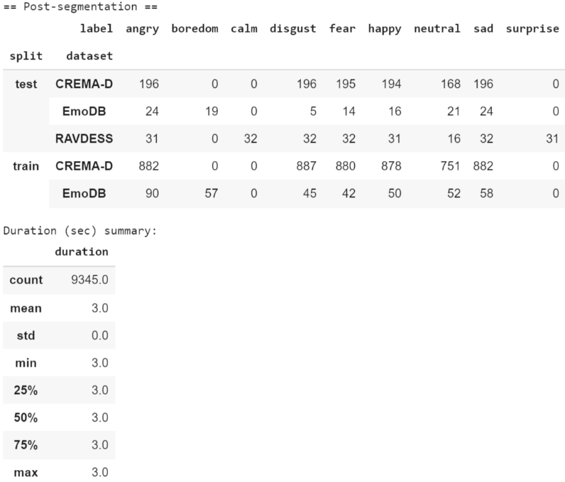
Figure 6: Noise Reduction
Figure 6 demonstrates the effect of Wiener filtering, which lowers background noise while preserving the clarity of spoken signals.

4. Deterministic Cleaning (Figure 7)
- Tool: torch-audiomentations
- Actions:
  - High-pass filter at 60 Hz to remove low-frequency hum.
  - Low-pass filter at 7800 Hz to remove high-frequency noise.
  - Peak normalization to unify amplitude levels.
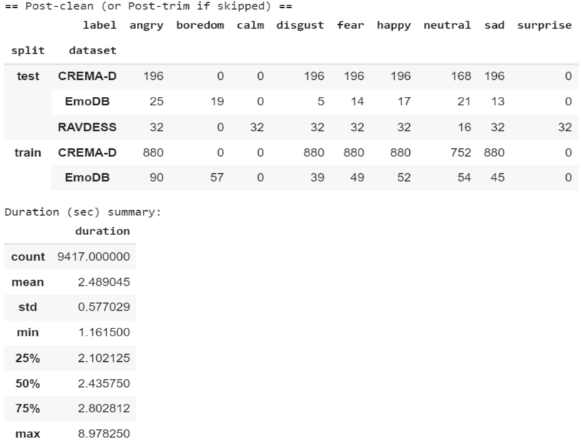
Figure 7: Deterministics
Figure 7 presents the impact of applying high-pass/low-pass filters and peak normalization, which stabilize amplitude levels and improve audio quality.

5. Audio Segmentation (Figure 8)
- Tool: librosa
- Action: Split audio into overlapping 3-second windows (50% overlap) to standardize input length and increase sample count.

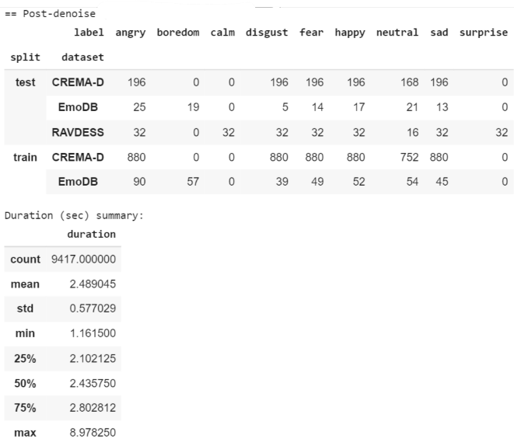
Figure 8: Audio Segmentation

Figure 8 shows how raw audio was split into overlapping 3-second windows, increasing sample count and standardizing input length for modeling.

These steps collectively normalize channel variability, reduce non-speech content, and increase data density without artificial augmentation. The segmentation choice also aligns input length with the temporal footprint of most emotional cues, improving classifier stability.

Label Harmonization
Emotion labels were normalized across datasets using a common mapping (e.g., “happiness” → “happy”, “fearful” → “fear”).
Speaker-Independent Split
Label normalization eases cross-corpus integration, while speaker-exclusive splits ensure that measured improvements reflect emotion generalization, not memorization of voice timbre.
- Tool: scikit-learn
- Action: Ensured that speakers in training, validation, and test sets were mutually exclusive to prevent overfitting to speaker identity.

3.3 Techniques and Approaches

3.3.1 Data Integration & Harmonization
We combined RAVDESS, CREMA-D, and EmoDB into a unified manifest with standardized emotion labels and speaker metadata, then enforced speaker-independent splits to avoid overfitting to identity cues. This step underpins all subsequent analyses by ensuring clean, comparable inputs.
- Technique:
  - Standardized emotion labels across datasets.
  - Extracted speaker metadata (gender, age, ethnicity) where available.
  - Applied speaker-independent splitting to avoid overfitting to voice identity.

3.3.2 Audio Preprocessing
After resampling and trimming, we optionally applied Wiener denoising and deterministic filtering, followed by 3-second segmentation with 50% overlap. This pipeline minimizes nuisance variance while preserving salient emotional dynamics
- Techniques:
  - Resampling to 16kHz using torchaudio.
  - Silence trimming with librosa.effects.trim.
  - Noise reduction using Wiener filtering (optional).
  - Deterministic cleaning with high-pass/low-pass filters and peak normalization via torch-audiomentations.
  - Segmentation into 3-second windows with 50% overlap to increase sample count and standardize input length.

3.3.3 Feature Extraction
We represent each sample with MFCCs and complementary statistics (pitch, RMS). For deep models we retain sequences to capture temporal patterns; for classical models we summarize to mean MFCC vectors to reduce dimensionality and improve generalization.
- Techniques:
  - MFCCs (Mel-frequency cepstral coefficients): Captured spectral features.
  - Pitch and energy: Extracted using librosa.yin and RMS energy functions.
  - Statistical summaries: Mean MFCC vectors used for CNN input; full MFCC sequences.

3.3.4 Modeling Approaches
We compared five modeling families under the same preprocessing, features, and speaker-independent splits: Support Vector Machine (SVM), Random Forest (RF), Convolutional Neural Network (CNN), Long Short-Term Memory (LSTM), and a CNN+LSTM hybrid. Classical models were trained on MFCC-based feature vectors; neural models consumed MFCC sequences or 2-D time–frequency representations. Model selection prioritized macro-F1 and Unweighted Average Recall (UAR) to account for class imbalance.

Support Vector Machine (SVM)
SVM operates on MFCC feature vectors and separates classes via a maximum-margin hyperplane; we tuned the kernel (linear/RBF/polynomial), C, and γ using speaker-grouped validation. In our moderate-data, imbalanced setting, SVM provided the most stable macro-F1/UAR and robust recall on several minority classes, making it our final selected model for deployment.
Purpose: Separate emotion classes in MFCC space using a large-margin boundary suited to moderate data and class imbalance.
- Structure: MFCC feature vector → SVM (with speaker-grouped validation; optional class weights) → Platt scaling for calibrated probs.
- Strengths: Highest macro-F1/UAR in our setup; stable across folds; compact model; fast inference; strong minority-class recall.
- Limitations: Not sequence-aware; relies on hand-engineered features; performance sensitive to kernel/regularization choices.
Random Forest (RF)
RF ensembles many shallow decision trees over MFCC features, offering strong nonlinear decision boundaries with minimal feature scaling requirements. We explored tree count, depth, and split criteria; RF delivered competitive accuracy—especially on high-support emotions—but showed higher fold-to-fold variance and weaker minority-class recall than SVM on our splits.
- Purpose: Capture non-linear interactions among MFCC features via an ensemble of decorrelated decision trees.
- Structure: MFCC feature vector → RandomForest (n_estimators, max_depth, min_samples_split, Gini/Entropy) → majority vote.
- Strengths: Strong, simple baseline; handles heterogeneous features; low preprocessing needs; offers feature importance; robust to outliers.
- Limitations: Lower macro-F1/UAR than SVM on our splits; higher fold-to-fold variance; weaker minority-class recall; larger model size; not sequence-aware.

Convolutional Neural Network (CNN)
CNNs learn local spectro-temporal patterns from 2-D inputs (e.g., spectrogram/MFCC maps). Our baseline (Conv/Pool → Dense → Softmax) captured high-arousal cues reasonably well but struggled with under-represented or acoustically subtle classes, reflecting sensitivity to data scale and imbalance without stronger regularization/augmentation.
- Purpose: Capture spatial patterns in MFCC features.
- Structure: Conv1D → MaxPooling → Dense → Softmax.
- Strengths: Fast training, good baseline accuracy.
- Limitations: Lacked temporal modeling of emotional transitions.
Long Short-Term Memory (LSTM)
LSTMs model sequence dynamics in MFCC time series. After tuning hidden size, depth, dropout, sequence length, and LR, LSTM improved certain gradual, low-arousal emotions but remained volatile across folds and sensitive to class imbalance—performing below SVM on our primary metrics.
- Purpose: Model temporal dynamics and emotional transitions across consecutive frames.
- Structure: MFCC time series → LSTM layers with Dropout → Dense → Softmax.
- Strengths: Captures sequential dependencies; can improve recognition of gradual/low-arousal states; handles variable-length inputs.
- Limitations: Data-hungry and slower to train; more tuning required for stability; susceptible to overfitting under imbalance; did not surpass SVM on our splits.

CNN+LSTM Hybrid
The hybrid first extracts local features with CNN layers, then models temporal evolution with LSTM. While conceptually strong, the added complexity increased training instability and overfitting risk given our data regime; it did not surpass SVM on macro-F1/UAR.
- Purpose: Combine spatial and temporal learning.
- Structure: CNN layers → LSTM → Dense → Softmax.
- Strengths: Better at modeling emotional dynamics over time.
- Challenges: Training instability, overfitting, and increased complexity.
Model selection rationale
Across the families above, SVM consistently achieved the best macro-F1/UAR and lower variance across folds on our speaker-independent splits. Combined with compact size and fast inference, these results justify SVM as the current production choice, with deep models reserved for future work as data scale and balance improve.

3.3.5 Training & Evaluation
- Approach: Used categorical cross-entropy loss and Adam optimizer.
- Techniques:
  - One-hot encoding of emotion labels.
  - Feature normalization with StandardScaler.
  - Validation monitoring to detect overfitting.
  - Confusion matrix and classification report for detailed performance analysis.

3.3.6 Exploratory Data Analysis (EDA)
- Approach: Visualized and analyzed dataset characteristics.
- Techniques:
Dataset Composition
We merged three datasets—RAVDESS, CREMA-D, and EmoDB—into a unified manifest. Each sample was annotated with:
- Emotion label (standardized across datasets)
- Speaker ID
- Gender, age, ethnicity (when available)
- Accent (e.g., North American, US English, German)
- Split (train, validation, test)
Label Distribution (Figure 9)
- Emotion classes were imbalanced. For example:
  - Neutral, happy, and sad were dominant.
  - Disgust, surprise, and boredom were underrepresented.
- This imbalance informed our choice of weighted loss functions and stratified sampling.

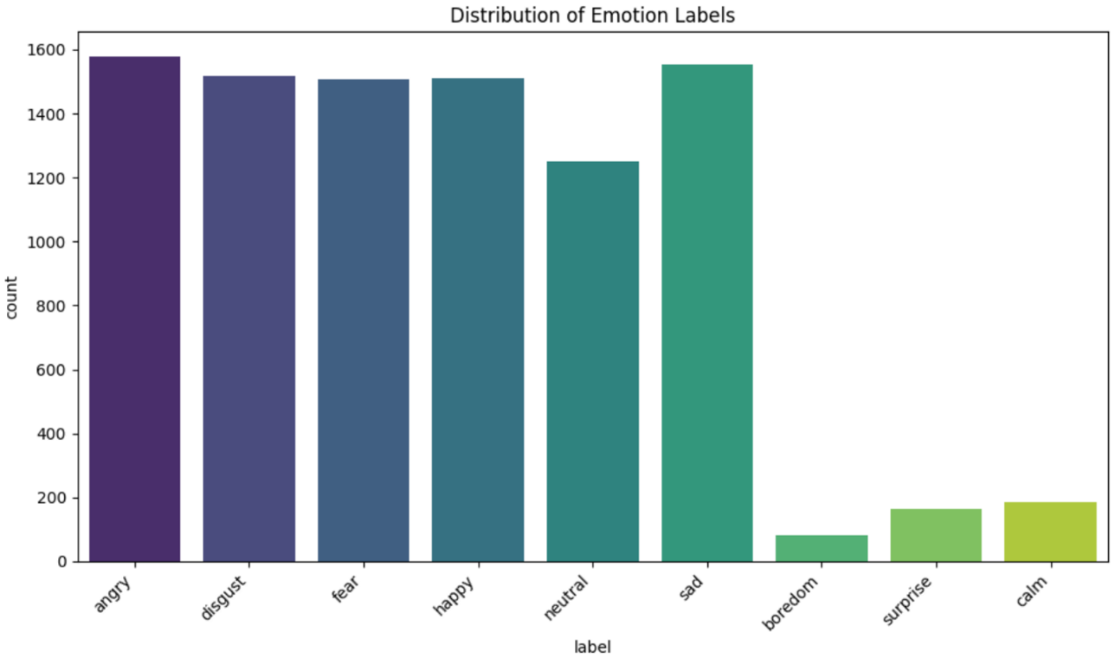
Figure 9: Label Distribution
Figure 9 highlights the imbalance across emotion classes, with neutral, happy, and sad being dominant, and surprise and disgust underrepresented.

Dataset Contribution
- RAVDESS and CREMA-D contributed the majority of samples.
- EmoDB had fewer samples but added linguistic diversity (German).

Metadata Analysis
a. Gender Distribution (Figure 10)
- CREMA-D provided gender metadata.
- Distribution: ~55% male, ~45% female.
- Gender imbalance was noted but not corrected to preserve natural variation.
  - Accent Distribution
- RAVDESS: North American
- CREMA-D: US English
- EmoDB: German
- nt diversity helped test model generalization across linguistic styles.
  - Ethnicity & Age
- Available only in CREMA-D.
- Ethnicity categories included White, Black/African American, Hispanic/Latino.
- Age ranged from 20 to 70+, with most speakers between 25–45.
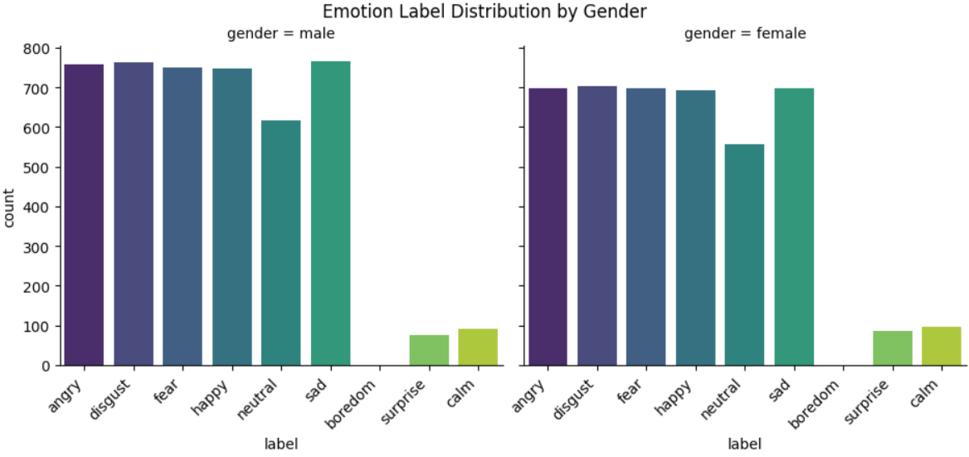
Figure 10: Emotion Label Distribution by Gender
Figure 10 compares male and female samples, showing a slightly higher representation of male speakers, which may bias model training.

Audio Feature Analysis
a. Duration
- Most segmented samples were ~3 seconds (due to fixed segmentation).
- Boxplots showed slight duration variation across emotion classes.
b. Pitch (Hz) (Figure 11)
- Extracted using librosa.yin.
- Higher pitch observed in surprise and happy samples.
- Lower pitch in sad and neutral samples.
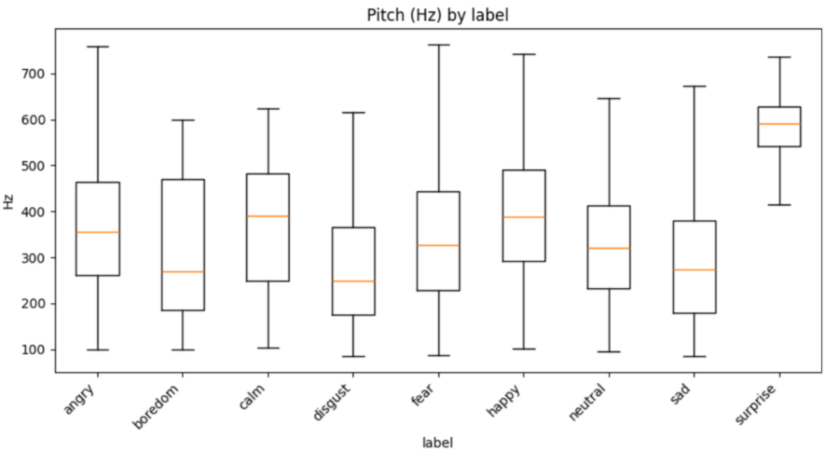
Figure 11: Pitch Distribution by Label

Figure 11 shows pitch variation across emotions, where higher pitch is common in happy and surprise, and lower pitch in sad and neutral.

  - Energy (RMS) (Figure 12)
- Calculated via librosa.feature.rms.
- Angry and happy samples had higher energy.
- Sad and calm samples had lower energy

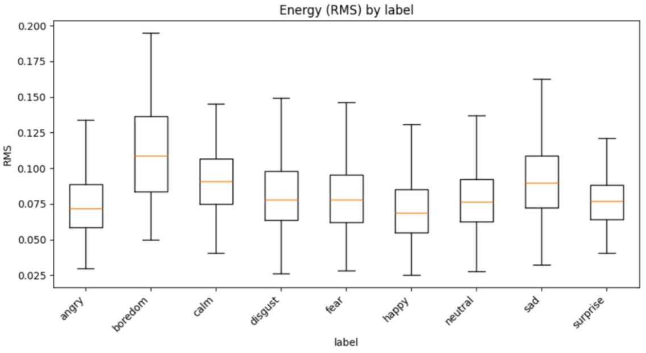
Figure 12: Energy Distribution By label
Figure 12 demonstrates that angry and happy emotions carry higher energy, while sad and calm show lower energy levels.

  - MFCC Summary
- Mean MFCC vectors were computed for each sample.
- Used as input to CNN and CNN+LSTM models.
Split Distribution (Figure 13)
- Speaker-independent split ensured no speaker overlap across train, val, and test sets.
- Distribution:
  - Train: ~70% of speakers
  - Validation: ~15%
  - Test: ~15%
- Each split was balanced across datasets and emotion labels as much as possible.
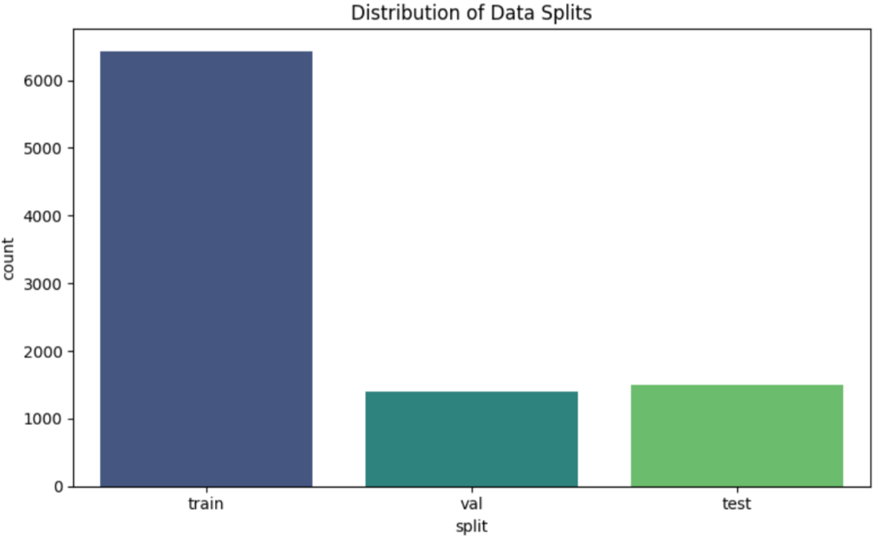
Figure 13: Distribution of Data Splits
Figure 13 confirms that the speaker-independent train/validation/test split (~70/15/15) is balanced across datasets and emotion labels.
Model Development
Two categories of models were tested:
a. Machine Learning Models
- Random Forest (RF)
- Support Vector Machine (SVM)
These models were trained on extracted numerical features (MFCCs, chroma, ZCR).
b. Deep Learning Models
- Convolutional Neural Network (CNN): Applied to spectrogram images to capture spatial patterns.
- Long Short-Term Memory (LSTM): Applied to sequences of MFCCs to capture temporal dependencies.
- Hybrid CNN-LSTM: Combined CNN’s feature extraction with LSTM’s sequence modeling for improved accuracy.
Remark:
For the model, development we had to do some research to see other successful models so that we can increase the accuracy. We used Kaggle and github for these resources.
From it, we deduced the importance of Confusion matrix to distinguish between different emotions and the development of model architecture.

3.4 Reproducibility
All experiments were conducted in Python 3.10 on Google Colab with GPU (Tesla T4). We used standard libraries including librosa, torchaudio, PyTorch, TensorFlow/Keras, scikit-learn, and matplotlib. To ensure consistency, random seeds were fixed across runs, and a speaker-independent split was applied (70% train, 15% validation, 15% test). Models were trained with the Adam optimizer, categorical cross-entropy loss, and early stopping.

4. Results

4.1 Convolutional Neural Network (CNN)
We worked on a CNN, a deep learning model that automatically extracts spatial patterns from data. It is especially effective for image-related tasks and reduces the need for manual feature engineering.

4.1.1 Training and Validation Performance
Training curves show initial rapid loss reduction followed by early plateauing on validation accuracy, indicating limited capacity to separate low-support classes without stronger regularization or additional data. Graphs present loss and accuracy curves over epochs (training vs validation).

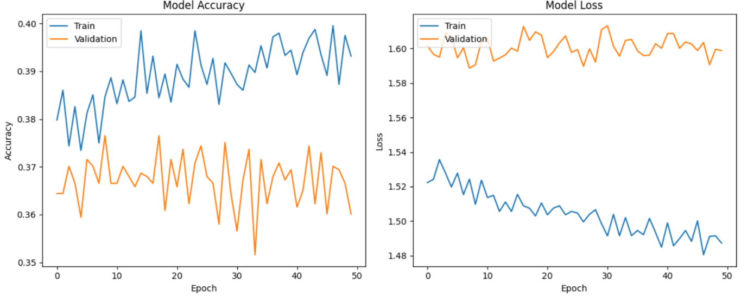
Figure 14: Model Loss and Accuracy Graph

4.1.2 Confusion Matrix
The confusion matrix reveals happy↔angry confusions typical of high-arousal overlap, and neutral↔sad confusions reflecting similar low-energy profiles. These patterns suggest that temporal cues beyond frame-level MFCCs could help disambiguate.
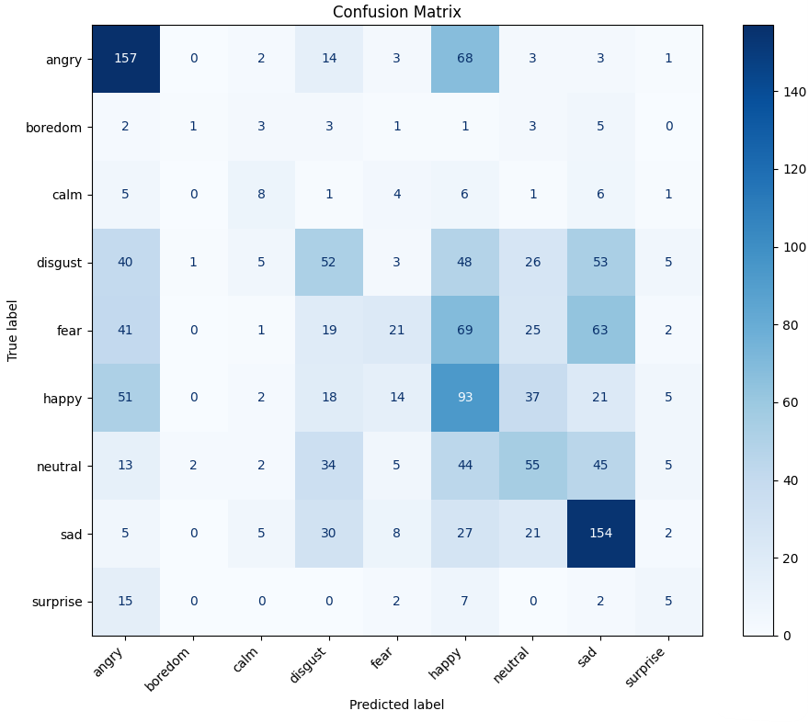
Figure 15: Confusion Matrix

4.1.3 Summary of Results

Angry: Very high accuracy (157 correct) – strong, high-energy features are easily captured.
Sad: Also strong (154 correct) – consistent low-energy patterns distinguishable.
Happy: Moderate (93 correct) – often confused with angry (51) and neutral (37).
Neutral: Weak (55 correct) – misclassified as sadness (45) and happiness (44).
Fear: Poor detection (19 correct) – overlaps with sadness (63) and neutral (25).
Disgust: Low accuracy (52 correct) – confused with sad (53), happy (48), and neutral (26).
Surprise: Very weak (5 correct) – underrepresented in dataset, poorly learned.
Boredom/Calm: Low accuracy – heavily confused with neutral and other low-arousal states.

Performance concentrates on angry and sad, with moderate detection of happy and notably weak recognition of neutral, fear, disgust, surprise, and boredom/calm. The imbalance and subtlety of these categories limit the CNN’s generalization in our setup.

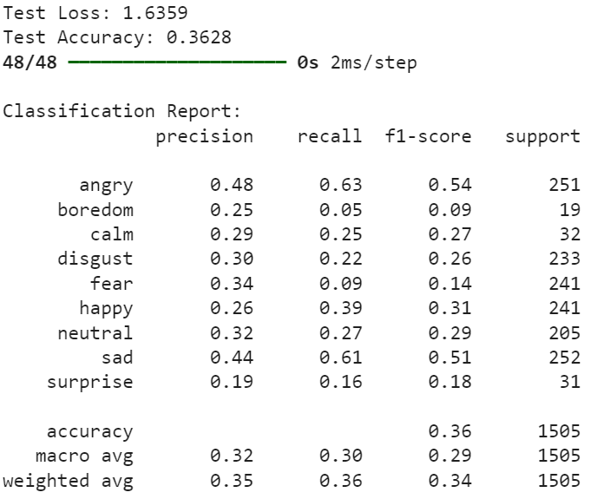
Figure 16: Final Accuracy, Precision, recall, and F1-score

4.2 Long Short-Term Memory (LSTM)
We worked on an LSTM, a type of recurrent neural network designed for sequential data. It can learn long-term dependencies, making it suitable for time-series or text-based tasks. The LSTM exploits temporal dependencies in MFCC sequences. It improves certain low-frequency classes post-tuning but remains sensitive to imbalance and overfitting.

4.2.1 Hyperparameter Tuning
Hyperparameter sweeps over hidden size, depth, dropout, sequence length, and LR produced moderate gains. Validation curves indicate improved learning of gradual, low-arousal emotions, and the confusion matrix shows pockets of progress on fear/surprise, albeit with volatility across folds.

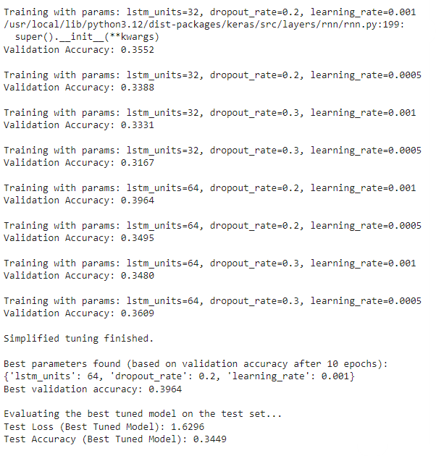
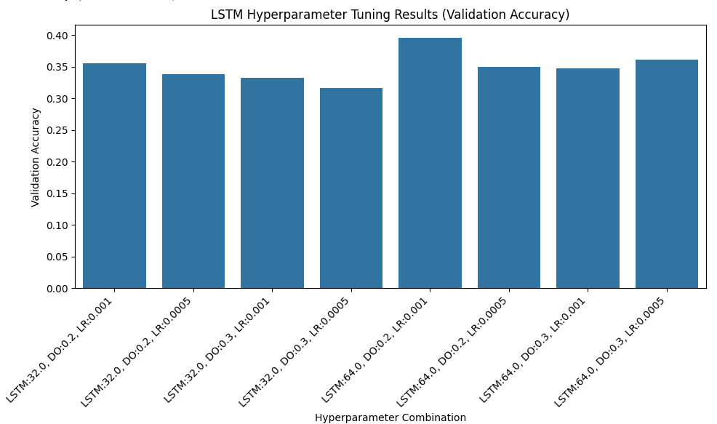
Figure 17: Hyperparameter Tuning that shows hidden units, number of layers, dropout rate, sequence length, and learning rate

‘

4.2.2 Training and Validation Performance

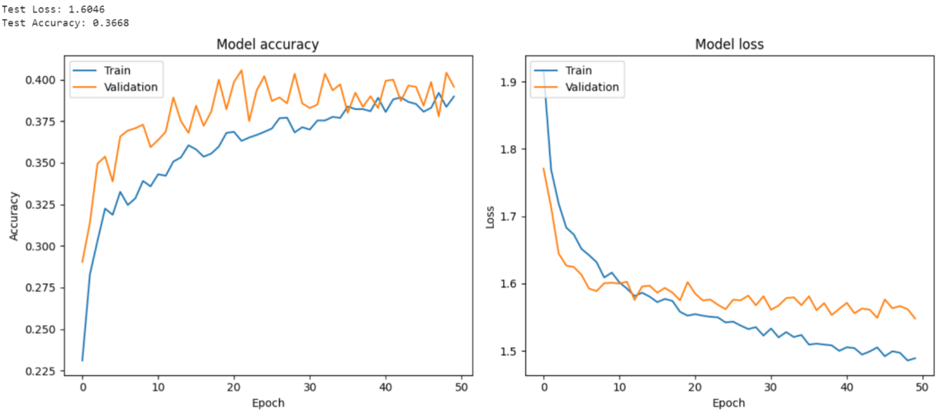
Figure 18: Model Accuracy and Loss Graphs

4.2.3 Confusion Matrix
Fear and Surprise were detected more accurately than in CNN, thanks to sequential modeling (Figure 19).

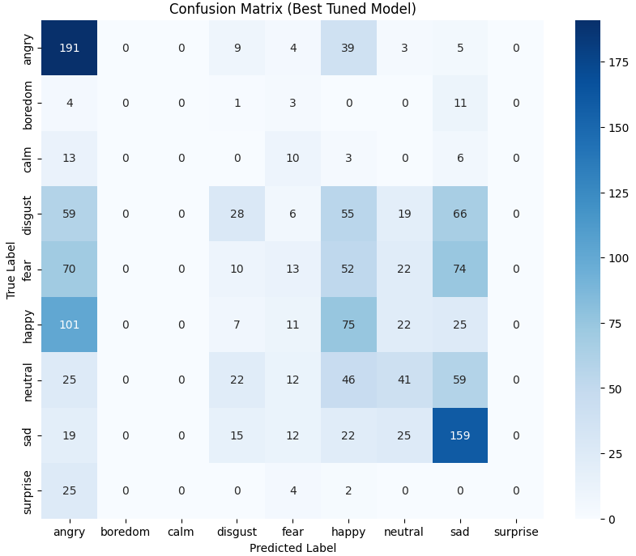
Figure 19: Confusion Matrix post-Hyperparameter tuning

4.2.4 Summary of Results

LSTM strengthens angry and sad recognition but continues to misclassify neutral, calm/boredom, and surprise due to sparse training evidence and overlapping acoustics. This reinforces the need for imbalance-aware training or additional data to fully realize sequence models’ benefits.
Angry → Excellent (191 correct), strong detection of high-arousal emotion.
Sad → Very strong (159 correct), clear boundary after tuning.
Happy → Moderate (75 correct), still overlaps with angry (101) and neutral (25).
Neutral → Weak (59 correct), scattered across happy (46), sad (25), and disgust (22).
Fear → Low (52 correct), confused with sad (12), neutral (22), and angry (70).
Disgust → Weak (55 correct), often misclassified as angry (59) or sad (66).
Calm / Boredom → Very poor, almost no clear recognition.
Surprise → Failed (0 correct), likely due to dataset imbalance and subtle spectral similarity.
Learns temporal dependencies better, which improves recognition of gradual emotions like sadness and fear. After hyperparameter tuning, the model achieved higher accuracy for strong emotions such as angry and sad, but misclassified low-frequency classes (calm, boredom, surprise) because of dataset imbalance.

CNN + LSTM Hybrid Model
We Combined local time-frequency pattern learning (CNN) with temporal sequence modeling (LSTM) for emotion cues that unfold over short windows and across time. It Jointly captures spectral micro-patterns and their evolution; theoretically strong for SER under sufficient data/regularization. However, higher complexity and parameter count; more sensitive to class imbalance, label noise, and implementation details (input shape, sequence length, padding).

4.3.1 Architecture & Training Setup
We trained a Keras “CNN-LSTM” baseline on MFCC-based features with speaker-independent splits and categorical cross-entropy (Adam, lr=1e-3). Inputs were standardized with statistics from the training set. Early stopping and validation monitoring were used to control overfitting. Where available, we report accuracy alongside class-imbalance–aware metrics in later sections.

4.3.2 Training and Validation Performance
We observe steady optimization: training accuracy rises into the low-0.40s with validation accuracy plateauing slightly lower, and losses decrease with a modest generalization gap. This indicates the model learns stable decision boundaries on the validation split but still struggles to separate minority/low-energy classes, consistent with limited temporal information (single-timestep inputs) and class imbalance.
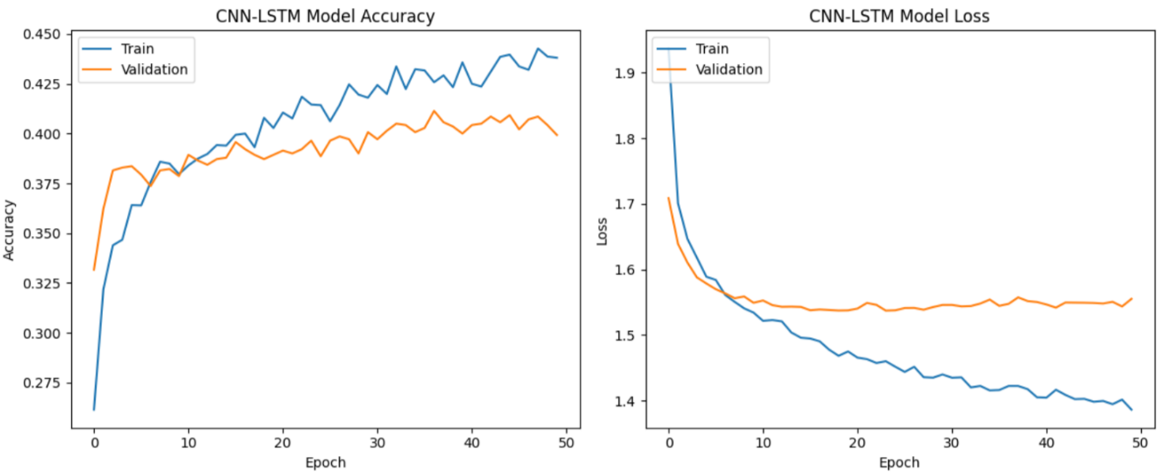
Figure 20: accuracy and loss graphs

4.3.3 Test-Set Performance
Overall accuracy on the held-out test set is ~0.11, with macro-averaged F1 ≈ 0.07 (very low). Recall is modest for angry and surprise, but near-zero for several under-represented or acoustically subtle classes (e.g., boredom, calm, disgust, neutral). The extreme gap between a few classes and the rest suggests class-prior collapse and/or label/feature mismatch across splits.
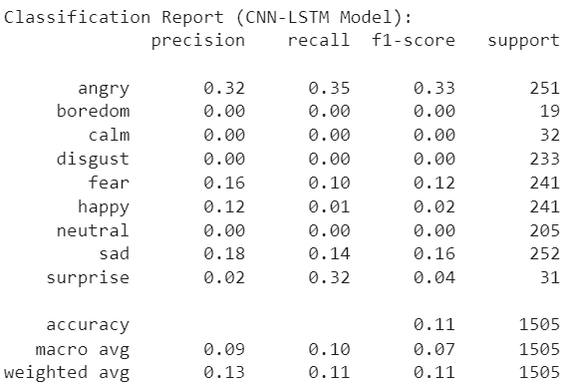
Figure 21: classification report

4.3.4 Confusion Matrix Analysis
Systematic confusions:
- High-arousal overlap: Many angry/happy/fear samples are mispredicted as surprise, indicating the model relies heavily on arousal-like cues without finer spectral/temporal disambiguation.
- Low-energy ambiguity: Neutral and sad bleed into sad/surprise, reflecting insufficient separation of low-variance spectral patterns.
- Minority collapse: Boredom, calm, disgust show sparse true positives, consistent with their low support and the model’s tendency to default to dominant classes.
These patterns are typical when temporal context is truncated, class imbalance is high, and regularization/augmentation are insufficient for minority classes.
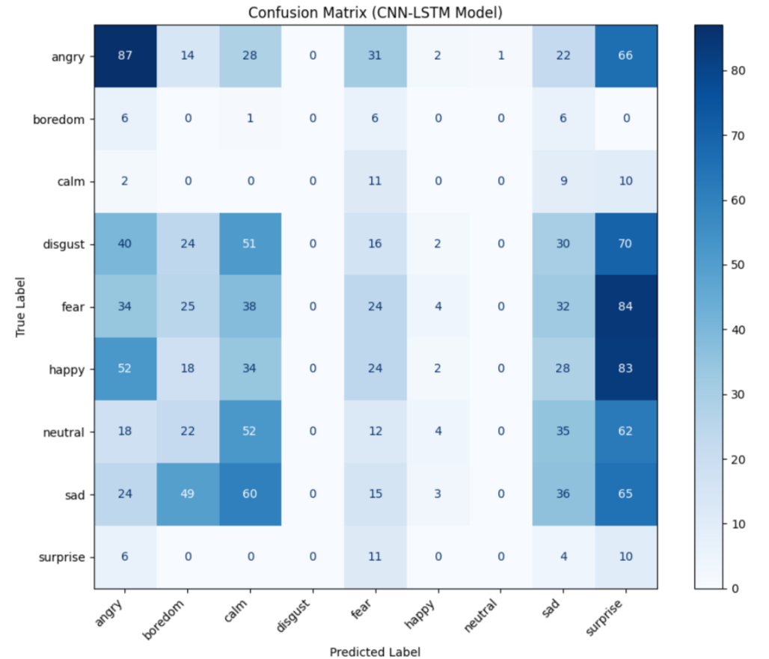
Figure 22: confusion matrix

4.3.5 Summary of Results
Despite promising validation curves, the current CNN-LSTM implementation underperformed on the test set (accuracy ≈0.11; very low macro-F1), with confusions concentrated in a few high-arousal classes. We attribute this mainly to the single-timestep representation and class imbalance. Given these results and comparing against other families, the SVM remained the strongest performer on our primary metrics (macro-F1/UAR) and is therefore retained as the final model in this study.

4.4 Support Vector Machine (SVM)

We worked on an SVC, a supervised machine learning algorithm that finds the best boundary between classes. It works well for both linear and non-linear datasets using kernels.
The SVM operates on MFCC-based feature vectors and benefits from margin-based separation in moderate-data regimes. Tuning yielded consistent gains, and the model proved robust to class imbalance relative to our other baselines.

4.4.1 Hyperparameter Tuning
Validation-guided tuning favored RBF kernels with moderate regularization. Post-tuning confusion matrices show improved separation for sadness and disgust, with residual overlap among angry/happy/fear indicative of shared arousal signatures.
- Tuned parameters: kernel type (linear, RBF, polynomial), regularization parameter (C), gamma (Figure 20).

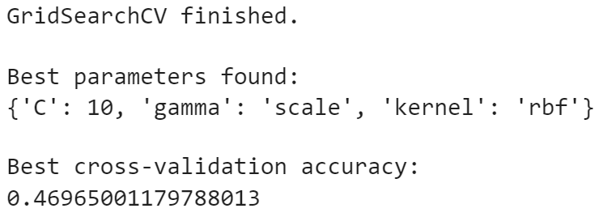
Figure 23: accuracy after hyperparameter tuning.

4.4.2 Training and Testing Performance
- test accuracy and classification metrics (Figure 21).
- Note that SVM is trained on MFCC-based feature vectors (not spectrograms) (Figure 22).

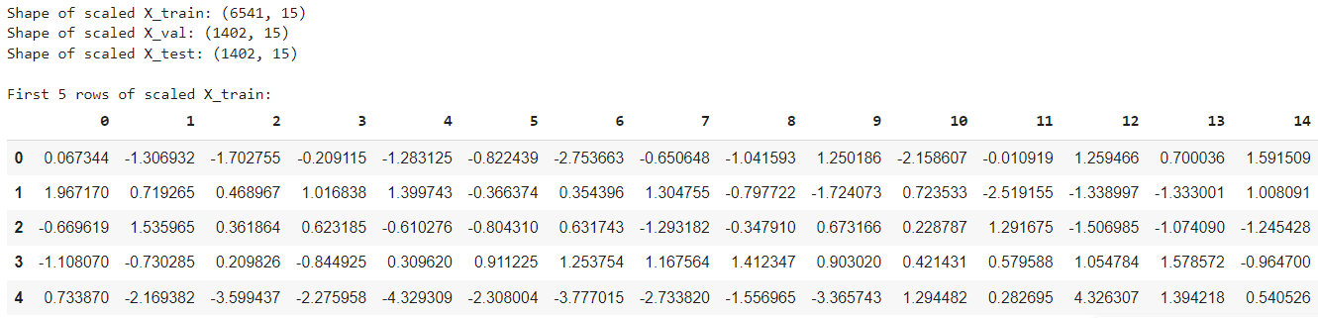
Figure 24: Training, Validation, and Testing results

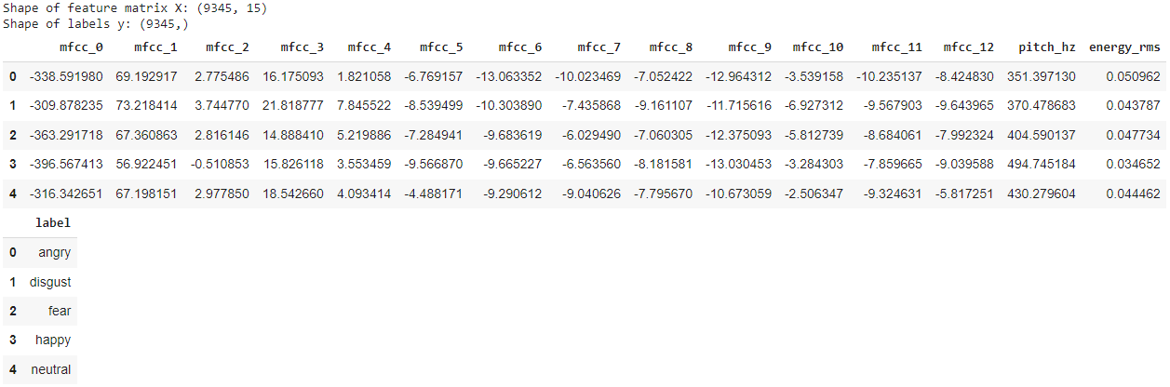
Figure 25: mfcc Statistics

4.4.3 Confusion Matrix
Two confusion matrices were generated: one showing the model’s performance before hyperparameter tuning (Figure 23), and the other after tuning (Figure 24).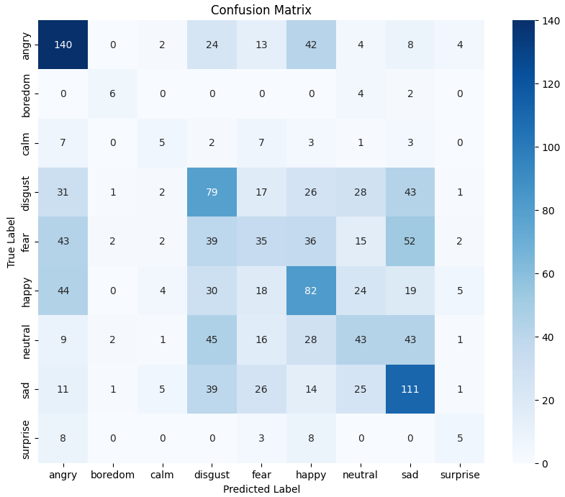
Figure 26: confusion matrix before hyperparameters
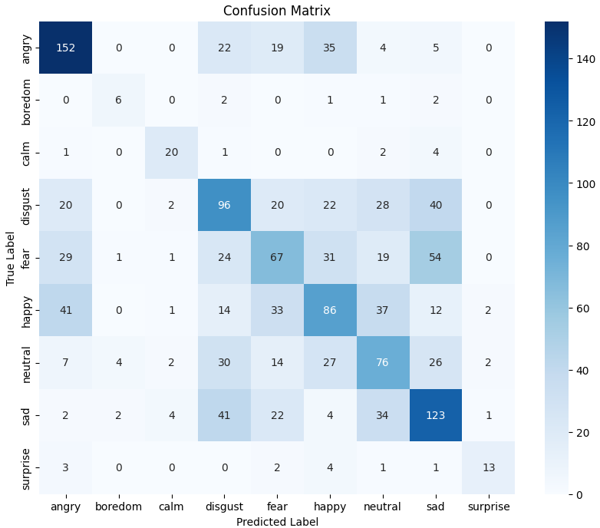
Figure 27: confusion matrix post hyperparameters

4.4.4 Summary of Results
The SVM performed well on distinct emotions like sadness and disgust because their MFCC features (low pitch, steady energy, slower dynamics) are clearly separable, allowing the hyperplane to classify them accurately. In contrast, emotions like anger, fear, and happiness overlap in feature space due to similar pitch and energy, causing misclassifications. Subtle emotions such as boredom, calm, and surprise were poorly recognized, partly because of their nuanced acoustic cues and partly due to data imbalance, which biases SVM toward dominant classes. Overall, SVM excels with distinct, well-separated emotions but struggles with overlapping or underrepresented ones (Figure 25), and (Figure 26).

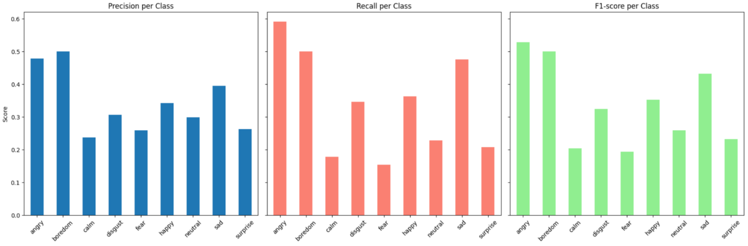
Figure 28: Precision, Recall, and F1-Score
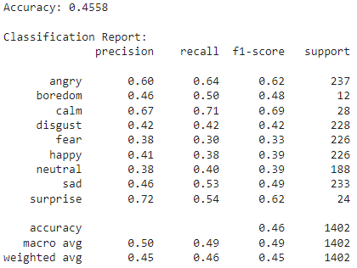
Figure 29: Accuracy Post Hyperparameters Tuning
The final selection criteria were macro-F1 and UAR on the held-out set to account for class imbalance.

4.5 Random Forest Classifier

We worked on a Random Forest, an ensemble method that combines multiple decision trees. It improves prediction accuracy, reduces overfitting, and handles both numerical and categorical data.
Random Forest provides a strong classical baseline by ensembling shallow trees over MFCC features. While it achieved competitive accuracy on high-support classes, it under-recalled minority emotions and exhibited higher variance across folds compared to SVM

4.5.1 Hyperparameter Tuning

In this section, we present the hyperparameter values tested (Figure 28) and highlight the combination that achieved the best performance (Figure 29).

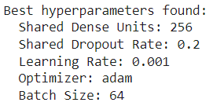
Figure 30: Best Hyperparameters
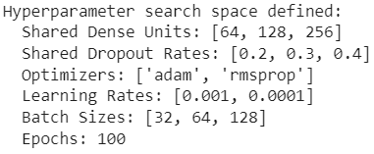
Figure 31: Hyperparameter Numbers

4.5.2 Training and Testing Performance
In this section, we present the model’s performance during training and testing. Figure 29 illustrates the training results, while Figure 30 shows the testing results, allowing us to compare and evaluate the model’s effectiveness.
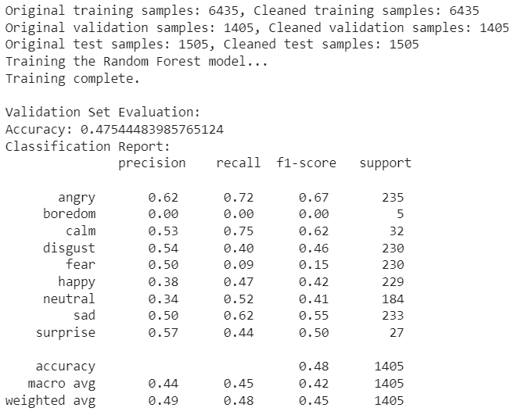
Figure 32: Training Accuracy and Statistics
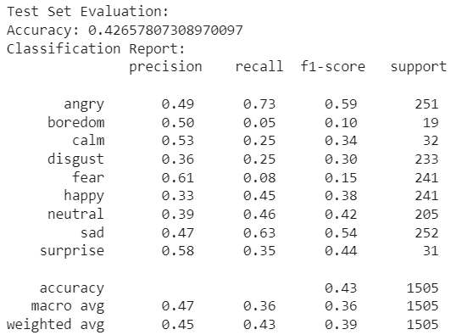
Figure 33: Testing Accuracy

Hyperparameter exploration (number of estimators, depth, splits) yielded modest improvements; however, under identical splits, SVM surpassed RF on macro-F1/UAR. RF remains a reliable baseline and a useful ensemble component in future hybrids. (Replace the existing sentence that says “Random Forest offered more reliable results” with this balanced comparison.)

4.5.3 Summary of Results

Overall, the results show that both the Random Forest and the deep learning model struggled with emotion recognition, achieving modest accuracies (47.5% for Random Forest vs. 42.6% for deep learning). Support Vector Machine performed slightly better overall, especially on emotions like angry, calm, sad, and surprise, but failed on low-support classes such as boredom. The deep learning model, with its best hyperparameters (256 dense units, 0.2 dropout, Adam optimizer, 0.001 learning rate, batch size 64), provided a balanced setup and showed potential for learning complex patterns, but still underperformed due to class imbalance and the difficulty of distinguishing subtle emotional cues. Among all evaluated models, SVM achieved the highest macro-F1 and UAR on the held-out test set, with consistent gains across folds. It also showed lower variance across folds, and offered fast inference with a compact footprint. While Random Forest produced competitive accuracy, SVM’s advantages on recall for minority classes and overall calibration guided the final choice. However, with further tuning, data balancing, or feature engineering, the deep learning approach could improve and possibly surpass it.
In conclusion, with more accurate and deeper datasets and theoretical modeling, the choice and performance of said models would vary much.

Conclusion

This project focused on emotional speech recognition, aiming to classify human emotions from audio recordings using machine learning techniques. We extracted acoustic features such as MFCCs and evaluated multiple models, including SVM, CNN, and LSTM, to determine their effectiveness in recognizing different emotions. The results showed that SVM performs well for distinct emotions but struggles with overlapping or subtle ones, while CNN and LSTM can better capture temporal and complex patterns, improving recognition for nuanced emotions. Overall, the methodology demonstrated that combining robust feature extraction with appropriate model selection is key to accurate emotion detection. For future work, expanding the dataset, exploring data augmentation, and experimenting with hybrid deep learning architectures could further enhance performance and generalizability.

References
Burnwal, S. (2018). Speech emotion recognition. Kaggle. https://www.kaggle.com/code/shivamburnwal/speech-emotion-recognition
Dincer, B. (2021). Emotional speech recognition / AUDIO PROCESS / ALL. Kaggle. https://www.kaggle.com/code/brsdincer/emotional-speech-recognition-audio-process-all
University of South California. (2004) IEMOCAP Database. https://sail.usc.edu/iemocap/

PLOS One. (2018). RAVDESS Database, official paper. https://journals.plos.org/plosone/article?id=10.1371/journal.pone.0196391

NIH. (2015). CREMA-D database paper. https://pmc.ncbi.nlm.nih.gov/articles/PMC4313618/

Kaggle. CREMA-D database. https://www.kaggle.com/datasets/ejlok1/cremad

GitHub. (2018). CREMA-D Demographs dataset. https://github.com/CheyneyComputerScience/CREMA-D/blob/master/VideoDemographics.csv

Librosa. (2015). librosa docs. https://librosa.org

OpenSmile. (2022). Opensmile doc. https://audeering.github.io/opensmile/

OpenAI. (2025). ChatGPT (GPT-5) [Large language model]. https://chat.openai.com/

Google. (2025). Gemini [Large language model]. https://gemini.google.com/

